Free counselling

Jaya Kudhail
Psychologist

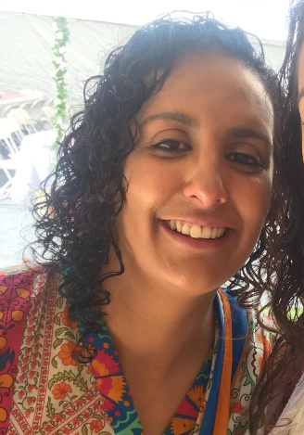
My name is Jaya Kudhail and I am a registered psychologist with over 10 years’ experience working in a range of settings. I have worked with youth and families as well as the area of cognitive impairment. I currently work in a correctional centre with men addressing addiction issues. I am an experienced group facilitator as well as someone with diverse clinical skills using a range of evidence-based modalities.

I am fully registered with AHPRA and currently hold board approved supervisor status.

I am a Sikh and was born in the UK and grew up in a little town called Southall. I am passionate about working with people from our cultural background to assist them with mental health issues, trauma, depression, anxiety, addictions and cognitive impairment to name but a few. I specialise in running groups and am currently would like to set up support groups for Punjabi women who have lost their partners and Punjabi women who have young children. I have worked with a diverse range of populations and can be flexible and adapt according to their needs. I speak Punjabi at a basic level and understand both Punjabi and Hindi.

I am a mother to 3 beautiful children and would like them to grow up and be kind people, who know who they are and give back to the community. This is my way of giving back to our community and hopefully making a difference one person at a time.

I think having support groups and individual sessions for people who cannot readily access mental health support but also debunk the stigma around talking about feelings and changing our thinking and attitudes towards asking for help so that our children grow up building their resilience and understanding and also not being afraid to ask for help.

Mental health affects 1 in 5 and our Punjabi community is not immune to this, but we need to find a better way to address stigma attached to seeking psychological assistance.

I am currently offering a support group for women who have lost their husbands as well as a group for new mums who on a bi-monthly basis. In addition to this I am offering 1 on 1 counselling sessions as well.

For enquiries and/or to book a session please contact Mandeep on:
Email: women.children@asaltd.org.au
Phone: 0401 132 459

